**Data Analyst - GS Challenge**

**Overview**

Please understand the below mentioned real-life scenario and try to solve the challenge.

**Business Scenario**

You are a data analyst and have a large ecommerce company in India (let’s call it X) as a client. X gets a few thousand orders via their website on a daily basis and they have to deliver them as fast as they can. For delivering the goods ordered by the customers, X has tied up with multiple courier companies in India who charge them some amount per delivery.

The charges are dependent upon two factors:

● Weight of the product

● Distance between the warehouse (pickup location) and customer’s delivery address (destination location)

On an average, the delivery charges are Rs. 100 per shipment. So if X ships 1,00,000 orders per month, they have to pay approximately Rs. 1 crore to the courier companies on a monthly basis as charges.

As the amount that X has to pay to the courier companies is very high, they want to verify if the charges levied by their partners per Order are correct.

**Input Data**

Left Hand Side (LHS) Data (X’s internal data spread across three reports)

● Website order report which will list Order IDs and various products (SKUs) part of each order. Order ID is common identifier between X’s order report and courier company invoice

● SKU master with gross weight of each product. This should be used to calculate total weight of each order and during analysis compare against one reported by courier company in their CSV invoice per Order ID. The courier company calculates weight in slabs of 0.5 KG multiples, so first you have to figure out the total weight of the shipment and then figure out applicable weight slabs.

For example:

- If the total weight is 400 gram then weight slab should be 0.5

- If the total weight is 950 gram then weight slab should be 1

- If the total weight is 1 KG then weight slab should be 1

- If the total weight is 2.2 KG then weight slab should be 2.5

* Warehouse pincode to All India pincode mapping (this should be used to figure out delivery zone (a/b/c/d/e) and during analysis compare against one reported by courier company in their CSV invoice per Order ID

RHS Data (courier company invoice in CSV file)

● Invoice in CSV file mentioning AWB Number (courier company’s own internal ID), Order ID (company X’s order ID), weight of shipment, warehouse pickup pincode, customer delivery pincode, zone of delivery, charges per shipment, type of shipment

● Courier charges rate card at weight slab and pincode level. If the invoice mentions “Forward charges” then only forward charges (“fwd”) should be applicable as per zone and fixed & additional weights based on weight slabs. If the invoice mentions “Forward and rto charges” then forward charges (“fwd”) and RTO charges (“rto”) should be applicable as per zone and fixed & additional weights based on weight slabs.

● For the first 0.5 KG, “fixed” rate as per the slab is applicable. For each additional 0.5 KG, “additional” weight in the same proportion is applicable. Total charges will be “fixed” + “total additional” if any

**Output Data 1**

Create a resultant CSV/Google Sheets file with the following columns:

* OrderNo
* AWB Code
* Customer Pincode
* Type of Shipment
* Forward Charges Applicable
* RTO Charges Applicable
* Total weight as per X (KG)
* Weight slab as per X (KG)
* Delivery zone as per X
* Forward_fixed _charges(X)
* Forward_additional_charges(X)
* RTO_Fixed_Charges(X)
* RTO_additional_Charges(X)
* Expected_charge as per X (Rs)
* Total weight as per Courier Company (KG)
* Weight slab charged by Courier Company (KG)
* Delivery Zone charged by Courier Company
* Charges Billed by Courier Company (Rs.)
* Difference Between Expected Charges and Billed Charges (Rs.)
* Discount Applied (%)
* Net Forward Charges (Rs.)
* Net RTO Charges (Rs.)
* Net Forward Charges per KG (Rs./KG)
* Net RTO Charges per KG (Rs./KG)

**Output Data 2**

Create a summary table

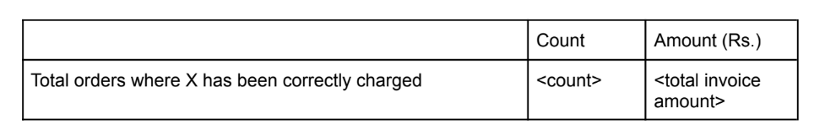

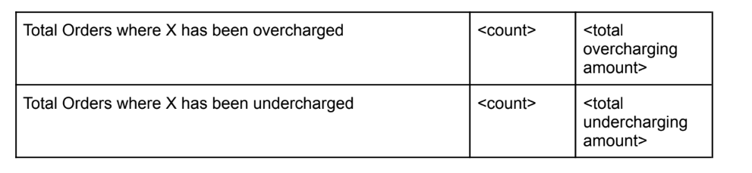

**Challenge Data Download**

Please download the challenge data from the following link:

<https://drive.google.com/file/d/1NjYY0t8ed4fcLEvgQl9DIqFluUkVL3GF/view>

**Submission**

Please submit the result in an Google Sheet with two workbooks (summary table in one and order level calculation in another) and your working (keep the formulas as is in the result).